There is a natural hierarchy of types of agent – which roughly aligns with their roles and capabilities in distributed applications:
Agent
An agent is an entity that can act; often on behalf of another entity. By extension, a software agent is one that acts primarily in the software domain.
The difference between an agent and a function is that the latter must be invoked before any actions in it’s body can be performed; whereas an agent is ‘already’ ready to act.
There is a vast potential range in capabilities of agents; for example, at a lower limit, one can argue that a thermostat can be viewed as a very simple agent – because it represents a localized responsibility for controlling the temperature in a room. Another common, though considerably more complex example, is the web browser: from the perspective of most web servers, browsers are agents that acts in the network for and on behalf of consumers.
There is even a fair amount of autonomy in browsers: modern browsers have features that attempt to keep their owners safe from phishing attacks and also are able to warn users that certain websites are dangerous to visit.
We have already encountered a Star feature that can be interpreted as being agent-like – the task. In fact, tasks have quite a few characteristics of autonomy: they can be performed in the background, they can collaborate via rendezvous and they can be used to implement systems involving multiple loci of activity.
However, a more accurate assessment would be that tasks and the rendezvous are good candidate technologies to realize an agent; just as bits of wire and bimetal can be bent together to make a thermostat. Moreover, Star’s concurrency concepts are more suited to constructing concurrent algorithms than whole distributed systems. This is because the primary issues that drive the complexity of distributed systems are different to those of concurrent algorithms: in particular, the necessity of handling communication between different computers.
Given the basic concept of agent, one might ask what are the characteristic attributes of an agent. Clearly, the most basic attribute is a capacity for action (this is built in to the definition of agenthood). A corollary of this is some kind of sensing capability – to determine what action to take (or not).
Once one can sense and act, the next required capability is the capacity to decide to act. This leads us to a hierarchy of introspective capabilities which we call cognition:
Cognitive Agent
A software agent that has an explicit representation of its own activities and capabilities.
Typically, this model takes the form of internal data structures that contain representations of some of the data the agent has (beliefs), some of the activities the agent is engaged in (actions) and some of the objectives the agent is pursuing (goals). Cognitive agents may also have explicit structures that describe the capabilities of the agent (plans).
Note that mechanical thermostats cannot be considered to be cognitive: there is no representation within a typical thermostat of its switching capabilities: it simply flips when the temperature moves; it cannot know that that is what it is doing – much less know about about the heating system it controls. On the other hand, some modern advanced computer-controlled thermostats certainly do understand that they are controlling heating and cooling systems.
Cognitive agent architectures are useful in situations where the activities of the agent are likely to be dynamic; perhaps responding to multiple stimuli, perhaps being able to perform a range of different capabilities.
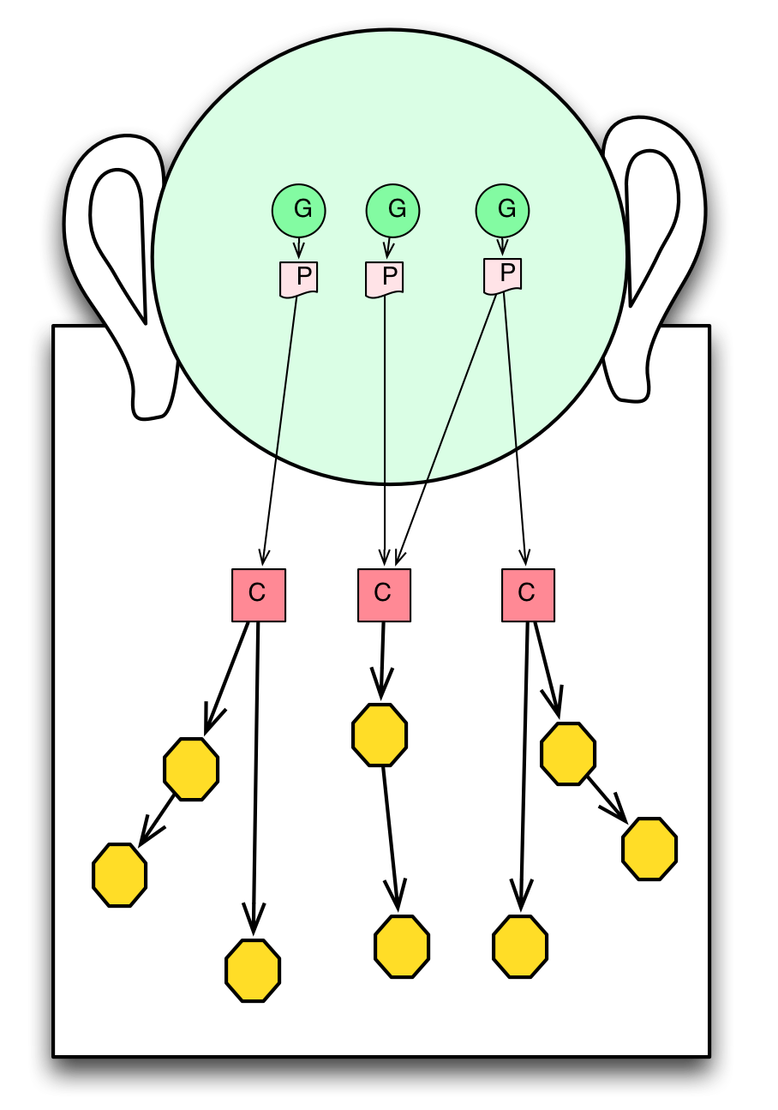
Cognitive Agent
A cognitive system can be interacted with at a higher level too. One can ask such a system if it is busy, for example.
One systematic way of endowing a software system with such a model is to model the beliefs, goals and ongoing actions as logical structures, perhaps as RDF graphs:
...
beliefs:graph[fact]
goals:graph[goal]
actions:graph[action]
capabilities:graph[plan]
...
Together, of course, with the semantics that links changes in the real world with changes in these variables and with rules that allow beliefs, goals and actions to be properly integrated.
We should also emphasize that many software systems already do have some limited cognitive capabilities. For example, a system with a ‘plug-in’ architecture can be said to have some awareness of its capabilities; similarly, in multi-threaded systems, task queues represent a simple form of self-awareness of current activities.
However, having a systematic representation of beliefs, desires, intentions and capabilities should simplify and accelerate the development of heterogenous agent-based applications.
While the difference between a ‘dumb agent’ and a cognitive agent may be one of degree, self-awareness is viewed as the major distinguishing feature of cognitive agents. Self-awareness is especially useful in situations where agents have to deal with complex overlapping scenarios; such as, for example, with human-computer interaction; or when trying to make sense of noisy physical data with multiple potential interpretations.
A self aware agent can even refuse to perform some activity – one of the more popular definitions of software agents is that they are autonomous systems. This can arise when a cognitive agent can measure the utility value for performing tasks: the basis for refusing to do something would be if the utility is below some threshold.
Even for agent systems that do have explicit representations of themselves there is always a large and deep ‘sub-conscious’ part of the agent – i.e., that part of the agent that is not modeled within the agent. It is simply not possible for an agent to know everything about itself – a situation familiar to most human agents.
Collaborative Agent
A collaborative agent is one which participates in a network of agents; and is able to achieve goals by involving other agents in the network. A particularly interesting case of collaboration is where one agent recruits one or more agents to help it achieve it’s goals.
Collaborative agents abound in distributed systems; for example, the triumvirate of the browser, the web server and the database server can be viewed as three collaborating agents.
Collaboration is independent of cognition. It is perfectly feasible to design networks of agents that have limited or no self-awareness. Conversely, cognitive agents are not required to participate in a network; although much of the motivation for self-awareness disappears if the agent has no-one to talk to.
The obvious hallmark of collaborative agents is communication: you cannot recruit others to do your bidding if you can’t talk to them. There are many styles of communication possible between software entities; the one that we suggest for use in Star agents is based on speech actions.

